Professional Development: Revisit Templates - Post Implementation
Speaker: Ms. Debbie Liberi, RET Resource Person and Grant Coordinator
Date: Tuesday, July 25th, 2017
Time: 10:45-11:30 AM
Venue: University of Cincinnati, Swift Hall, Room 516

Prepared by:
Ryan Wright, Ryle High School, Union, KY
RET Participant for Project #3: “Bio-inspired optimization of the travelling salesmen problem”

This session was given by Ms. Debbie Liberi, RET Resource Person on Tuesday, July 25th, 2017 from 10:45-11:30 AM at the University of Cincinnati in Swift Hall, room 516. Debbie Liberi currently serves as the District Coordinator for the CEEMS grant at UC and as Coordinator for the RET Program. She earned BA in Biology at Wittenberg University and a Masters in Secondary Educations from UC, as well as, a Masters in Library and Information Science from Kent State University. She was a middle school science teacher and high school librarian for 35 years with CPS. From 2000-2010, Debbie was a National Board Certified Teacher in Early Adolescence Science. She also served as a lead teacher in various mentoring roles for CPS. In addition, Debbie has served as an adjunct faculty in the Teachers College at UC and at Xavier University.
Ms. Liberi began by passing out a stack of handouts and highlighters to everyone in attendance. She also asked that everyone get out their RET binders as it contained some of the paperwork that would be covered during the presentation. She started by going over some objectives of the presentation, spelling out exactly what would be covered during the course of the timeframe. The presentation then shifted towards a short pre-assessment quiz designed to measure what attendees already knew about what they would be doing throughout the course of the school year (Fig. 1). She then led the class in a discussion of this quiz before transitioning to her presentation. As the class went through her presentation, they were able to follow along via printed copies of the slides in front of them (Fig. 2).
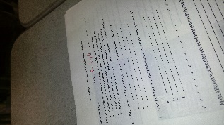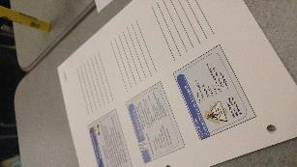
Fig 1: The pre-quiz Fig 2: Slide Printouts
The presentation then shifted towards things that needed to be revisited and completed after implementing the unit (Fig. 3). A large portion of the presentation was focused on reporting results after implementation of the designed unit. Ms. Liberi stressed the benefit of graphing data and making it very visual for readers, as well as including an analysis paragraph or two for any data included. She pointed out that including samples of student work can leave a strong impression on anyone reading about the unit, as well as giving an indication of how students performed. Finally, she mentioned that student interviews, surveys, and videos can really help paint a picture of what students thought about the unit and provide valuable feedback.
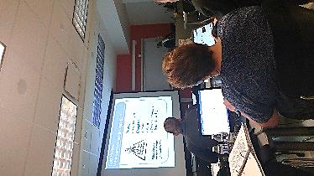
Fig. 3: Discussing Post-Unit Materials
The presentation ended with a discussion of the reflections that would need to be completed after teaching the unit. Ms. Liberi provided a specific list of questions that teachers should ask themselves after utilizing their units, and these questions should be answered in the “reflections” section of the unit template post-implementation. These answers can help shape how teachers tackle the unit in future years if they decide to do so, so reflecting on how it went can help fine-tune it and make it even better. The presentation then concluded with a quick walk-through if the included checklist, which covers everything that must be completed as a part of the RET program. Teachers were able to check off several things on the list already, and looking at the list allowed the RET teachers to start planning ahead about what might be their next step.

